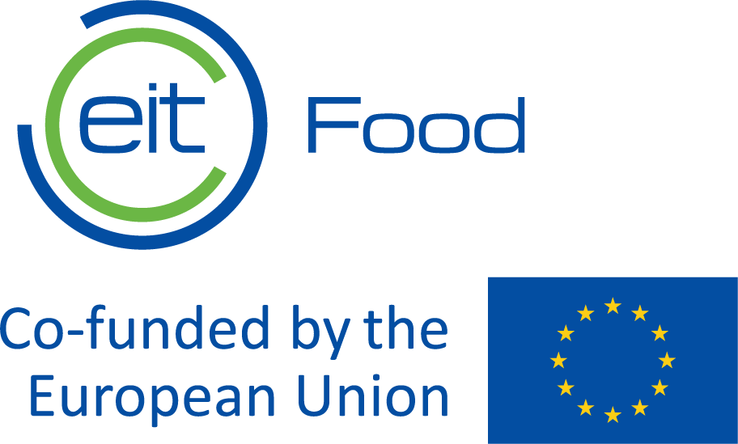

Request for proposals
OPEN CALL
for Public Affairs
consulting services
to EIT Food

EIT Food – Making Food Innovation Happen

Knowledge & Innovation Center on Food,
part of the European Institute of Innovation and Technology (EIT)
V0.1 - 19 November 2020 (First Update)

http://www.eitfood.eu

Table of contents

Table of contents 2
1. Overview of EIT Food 3
2. Scope of work 3
3. Proposal Process 6
3.1. Participation 6
3.2. Submission of proposal 6
3.3. Validity of the proposals 7
3.4. Requests for additional information or clarification 7
3.5. Costs for preparing proposals 7
3.6. Clarification related to the submitted proposals 7
3.7. Negotiation about the submitted proposal 7
3.8. Evaluation of proposals 8
3.9. Appeals/complaints 8
3.10. Signature of contract 8
3.11. Cancellation of the proposal procedure 9
3.12. Ethics clauses / Corruptive practices 9
3.13. Annexes 9

Overview of EIT Food
EIT Food is Europe’s leading food innovation initiative, working to make the food system more sustainable, healthy and trusted.
The initiative is made up of a consortium of key industry players, startups, research centres and universities from across Europe. It is one of nine Innovation Communities established by the European Institute for Innovation & Technology (EIT), an independent EU body set up in 2008 to drive innovation and entrepreneurship across Europe.
EIT Food aims to collaborate closely with stakeholders across the entire value chain to develop new knowledge and technology-based products and services that will ultimately deliver a healthier and more sustainable lifestyle for all European citizens.
For more information about our company please visit the following website: www.eitfood.eu

Scope of work
- GENERAL OBJECTIVES:
Providing dedicated, reliable, on-going expert support and advice to EIT Food in Public Affairs, contributing to
- Increase visibility and recognition by EU and national policy makers
- Identify, create, and assist in the exploitation of opportunities to strengthen EIT Food’s position as thought leader
- Identify and assist in the exploitation of opportunities to diversify sources of financing.

- DETAILED WORK SCOPE:
  - Eyes & Ears - monitoring, alerts and briefings: providing regular insights and analyses of issues relevant to food system transformation, innovation, competitiveness, market players & stakeholders.
  - Policy – identify and fill opportunities to make EIT Food community’s voice heard in the EU legislative and non-legislative processes. Anticipate, draft contributions and amendments; support practical approach to engage effectively with decision makers; help organise meetings and events, also with other associations, think tanks, and partnerships, where relevant and efficient; monitor progress, share feedback, follow up and advise on adapting tactics for maximum impact.
  - Institutional relations: support EIT Food in developing and consolidating effective relations to key decision makers and intermediaries, focussing, not exclusively, on the European Commission, Parliament, Investment Bank and Fund, Social and Environmental Committee, Committee of the Regions, Member States and key stakeholders in agriculture and food, with innovation, entrepreneurship, finance and scale ups as cross cutting issues in these sectors.
  - Funding opportunities: provide regular, detailed updates on opportunities for EIT Food and its partners to participate in projects and initiatives where the community’s expertise, knowledge and track record make for competitive advantages that can generate additional sources of financing.

- DELIVERABLES:
  - Weekly coordination calls
  - Strategic coordination meetings sticking to EU agenda
  - Regular, ad hoc, highly practical and actionable recommendations
  - Policy updates newsletter every 2 weeks newsletter
  - Targeted alerts and availability to elaborate on related action plans (early warning approach)
  - Relevant mappings, e.g. on national stakeholders, influential think tanks, possible contacts for fresh alliances with other representations to the EU, MEPs, Commissioners’ cabinets, DGs, etc.
  - Regular updates on key legislative and non regulatory files crucial to EIT Food Public Affairs strategy and actions.
  - Expert monitoring, analysis and briefings on technical, highly specific EU files, initiatives, programmes, instruments, partnerships and stakeholders’positioning
  - Support to build alliances, media coverage, and recognition among defining circles of influence
  - Dedicated briefings, notes, presentations for EIT Food teams, Public Affairs and beyond – e.g. Public Engagement & Insights, Education, Innovation and Business Creation Teams, for management and the supervisory board, for Think Tanks, regional offices, partners, project leaders, speakers representing EIT Food, etc.
  - Institutional meetings organisation, preparation and follow up
  - Coordination with the European Food Forum at the European Parliament and similar platforms when relevant
  - Identification of speaking opportunities and contribution to messaging, copy writing and dissemination plans
  - Building, drafting, updating position papers, policy recommendations, presentations and speeches for EIT Food, including its Protein Diversification Think Tank and Consumer Advisory Board members
  - Representing EIT Food at EU events where and when necessary
  - Clear, regular and lean reporting on progress
  - Assistance in reporting by EIT Food PA team
  - Close monitoring of costs, alerts & early warning system in place concerning expenditures, possible budget diversions, with recommendations allowing EIT Food to anticipate.
  - Any other product / service the tenderer considers can add extra value.

This is a non-exhaustive list of possible deliverables. Concrete deliverables shall be defined in the yearly Scope of Work (SoW) agreements and adjusted considering emerging priorities.

- METHODOLOGY AND ORGANISATION OF WORK:
  - Tenderers are expected to propose and discuss a strong methodological approach. We would like to hear about
    - the definition and measuring of impact and success,
    - flexibility,
    - ad hoc expert support in key files such as the CAP and FP10, carbon mechanisms, soils, sustainable agriculture, fair food prices, farmers, consumers, etc.
    - efficient engagement strategies,
    - close cooperation.
A calendar of activities must be provided including regular meetings with EIT Food Public Affairs
for strategic and tactical reviews as well as recommendations for a quick launch of the cooperation in 2025.
  - A vision for EIT Food Public Affairs should be discussed in the proposal, looking at various scenarios where the variables may include: the EU updated strategy and its implications for food systems, the new EC priorities, portfolios, work programmes, Member States’ positions, innovation instruments and budgets, etc. We would like to read how work will be organised and possibly adapted over time under the various scenarios.
  - The tenderer must propose a clear plan for support to EIT Food Public Affairs in 2025, including key milestones, review times, space for brainstorming, recommendations to sharpen the organisation’s footprint in Brussels and EU capitals.
  - Additional suggestions beyond the outlined deliverables are encouraged and appreciated.
- TIMING and PLANNING:
  - The contract is expected to start as early as possible in 2025.
  - It is a multiannual, framework contract envisaged for 3 years, with annual plans / scope of work to be updated every year on a concrete, precise basis – i.e. including detailed action and support plans.
  - A detailed plan for the 1st year of this multiannual contract must be provided as a response to this call with proposed objectives and suggestions for key activities in year 2 (2026) and year 3 (2027).
  - Comments on how to ensure adequate planning are welcome.

Proposal Process

Participation
Participation in this proposal procedure is open to all tenderers.

Submission of proposal
 | Date
Sending out RFP invitations to the potential suppliers | 16 September 2024
Deadline for requesting clarification from EIT Food | 24 September 2024
Deadline for submitting proposals | 28 October 2024
Intended date of notification of award | 20 November 2024
Intended date of contract signature | As of 1st December 2024

Proposals must be emailed in English to the following E-mail address: marie-elisabeth.rusling@eitfood.eu
For the attention of Mrs Marie-Elisabeth RUSLING, Head of Public Affairs
The proposal shall contain:
- the technical response to the services requested (point 2)
- the financial offer (the price for the services.) The Financial offer shall be expressed in Euros, VAT shall be indicated separately. See Annex III.
Responses should be concise and clear. The tenderer’s proposal will be incorporated into any contract that results from this procedure. Tenderers are, therefore, cautioned not to make claims or statements that they are not prepared to commit to contractually. Subsequent modifications and counterproposals, if applicable, shall also become an integral part of any resulting contract.
The tenderer confirms that the individual submitting the natural or legal entity’s proposal is duly authorized to bind its entity to the proposal as submitted. The tenderer also confirms that it has read the instructions to tenderers and has the experience, skills and resources to perform, according to conditions set forth in this proposal and the tenderers’ proposal.

Validity of the proposals
Tenderers are bound by their proposals for 90 days after the deadline for submitting proposals or until they have been notified of non-award.
The selected winner must maintain its proposal for a further 60 to close the contract.
Proposals not following the instructions of this Request for Proposal can be rejected by EIT Food.

Requests for additional information or clarification
In case the tenderers require additional information or clarifications, these should be addressed to the person indicated below. All communication between EIT Food and tenderers is only possible in writing, all requests will be done and answered by e-mail only. All questions should be sent prior to deadline for requesting clarification as specified in Section 3.1. In case of complex or high value procurements, EIT Food may arrange a clarification session of which it will inform all tenderers.
Contact name: for the attention of Ms Rusling Head of Public Affairs EIT Food
E-mail : marie-elisabeth.rusling@eitfood.eu
EIT Food has no obligation to provide clarification.

Costs for preparing proposals
No costs incurred by the tenderer in preparing and submitting the proposal are reimbursable. All such costs must be borne by the tenderer.

Clarification related to the submitted proposals
After submission of the proposals, they shall be checked if they satisfy all the formal requirements set out in the proposal dossier. Where information or documentation submitted by the tenderers are or appears to be incomplete or erroneous or where specific documents are missing, EIT Food may request the tenderer concerned to submit, supplement, clarify or complete the relevant information or documentation within an appropriate time limit. All communication between EIT Food and tenderers is only possible in writing, all requests will be done and answered by e-mail only.

Negotiation about the submitted proposal
After checking the administrative compliance of the tenderers, EIT Food reserves the right to negotiate the contract terms with the tenderers. In this negotiation EIT Food may ask all tenderers to adjust the proposal or specific sections of the proposal within an appropriate time limit. In case of negotiation, EIT Food shall provide further information about the proceedings and timing.

Evaluation of proposals
The quality of each proposal will be evaluated in accordance with the below mentioned award criteria. The award criteria will be examined in accordance with the requested service indicated in Section 2 of the document.
Award criteria:
- Project experience, competences and availability of the members of the proposed project team (15 points)

- Methodology approach of project and effectiveness of the proposed implementation plan (30 points)
- Extra offer and suggestions to improve EIT Food stance and address its current and future challenges (15 points)
Total technical score: 60 points maximum
- Price or total cost: lowest offered expert unit price shall receive the highest score; the score for other offers shall be calculated in relation to that in linear equation (maximum: 40 points)
Total financial score: 40 points maximum
Total maximum score: 100 points
The results of the award procedure will be communicated in writing (via e-mail) to the successful and unsuccessful tenderers.

Appeals/complaints
Tenderers believing that they have been harmed by an error or irregularity during the award process may file a complaint. Appeals should be addressed to EIT Food. The tenderers have 10 calendar days to file their complaints from the dispatch of the award notification e-mail

Signature of contract
Please refer to Annex 1 for the template contract that shall apply to this procedure. Any changes desired by the tenderer in the provisions contained in the body of this Service Agreement must be communicated to EIT Food as part of the proposal of such tenderer. Any such changes will be considered as part of the evaluation of the proposal of each tenderer
Note: Should the tenderer insist on using their own template, a draft contract needs to submitted along with the tender proposal. Use of supplier template is only possible after review and approval from EIT Food’s Procurement and Contracts Officer.
Within 5 days of receipt of the contract from EIT Food, the winning tenderer shall sign and date the contract and return it to EIT Food. Upon receipt, EIT Food shall countersign and return one signed copy of the contract to the winning tenderer.

Cancellation of the proposal procedure
In the event of cancellation of the procurement procedure, EIT Food will notify tenderers of the cancellation. In no event shall EIT Food be liable for any damages whatsoever including, without limitation, damages for loss of profits, in any way connected with the cancellation of a proposal procedure, even if EIT Food has been advised of the possibility of damages.

Ethics clauses / Corruptive practices
EIT Food reserves the right to suspend or cancel the procedure, where the award procedure proves to have been subject to substantial errors, irregularities or fraud. If substantial errors, irregularities or fraud are discovered after the award of the Contract, EIT Food may refrain from concluding the Contract.
The supplier shall take all measures to prevent any situation where the impartial and objective implementation of the contract is compromised for reasons involving economic interest, political or national affinity, family or emotional ties or any other shared interest (‘conflict of interests’). The supplier should immediately inform EIT Food if there is any change in the above circumstances at any stage during the implementation of the tasks.

Annexes
Annex I: Contract Template.
The Contract Template is provided for information purposes only and might be subject to considerable modifications.
Annex II: Declaration of Honour
Annex III: Financial tender submission template.

